

How to register for the IDA Conference

1. Create an account

To register for the conference and social activities, you must first create and IDA account. To do this, [PLEASE CLICK HERE.](https://portal.irishdentalassoc.ie/Site-Access/Registration-Select)  Once you are on the registration page, pick the new user option to create your account. You will then have to complete the registration form.

*please note, when creating a username, there can be no spaces or special characters (%”!) in the username.

*Passwords must consist of uppercase letters, lowercase letters and numbers only, no special characters.

*For Dental Council number, please input your regional or national dental registration number.

1. Registering for the events

Once your registration is complete, you will be brought to your homepage, as seen below:

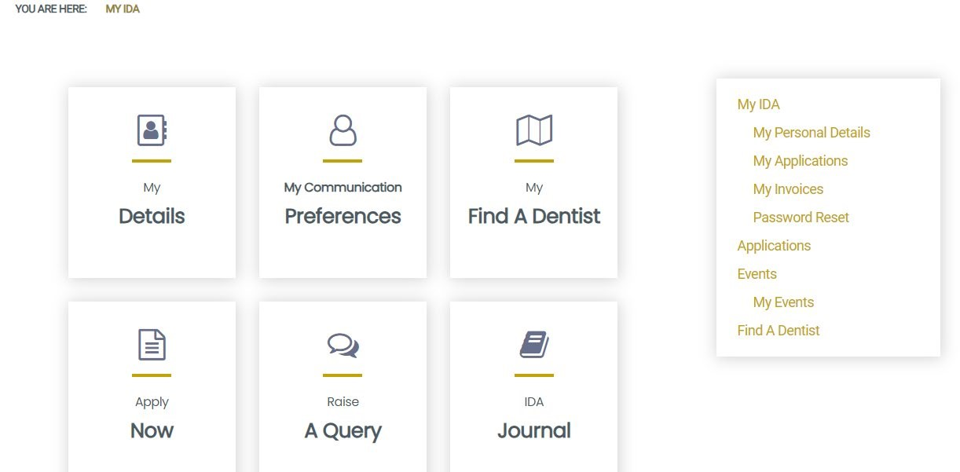



To book your event, choose Events from the menu tab on the right hand side. Once this is done, you will be able to find the events you want to book and follow through the booking form. Please note, if you are booking the conference and events from the social programme, you will need to do these separately.

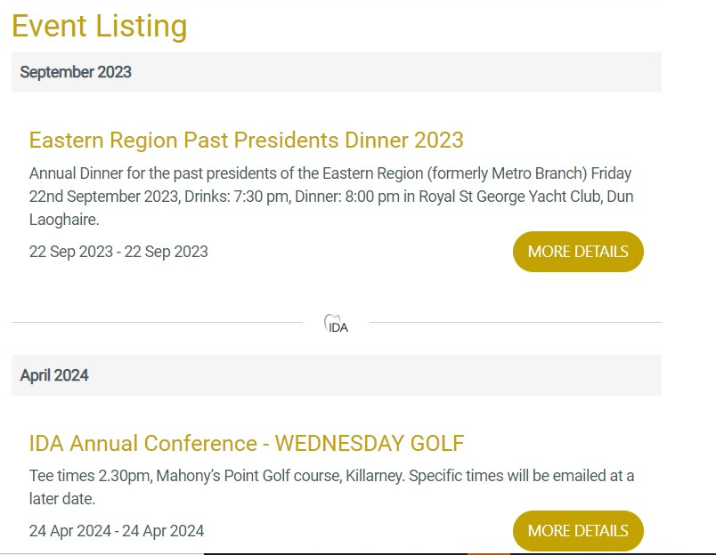

Once you have booked all your desired events, they will appear in the My Events section of the menu.

If you have any difficulties at all, please email Aoife Kavanagh at aoife@irishdentalassoc.ie.

Looking forward to welcoming you to Killarney in April 2024!